Version: 1.0 | Date: 01.01.2009 | From: Véronique Robaire
Subject: Vendor Consignment Stock
Valid for: | ARaymond Group
Additionnal information completed by AR France (J. LELIEVRE) – 05/11/2013
Additional information completed by AR France (J. LELIEVRE) – 29/07/2015
Reversal solution (X. Lapray, E. Raclot) – 04/11/2015

Content

1. Process explanation 2
1.1 Material master 2
1.2 Create a purchase info-record type “K” 2
1.3 Create a purchase requisition with item category “K” 2
1.4 Create a purchase order with item category “K” 3
1.5 Non valuated goods receipt (MIGO) 3
1.6 Quality control (transfer from “Q” to unrestricted use) 3
1.7 Display consignment stock with MB54 4
1.8 Goods issue on production order from consignment stock 4
1.9 Transfer from consignment stock to own stock 4
1.10 Scrap consignment stock 4
1.11 Goods return to vendor 4
1.12 Settling Consignment Liabilities 4
1.13 Physical Inventory of Consignment Material 5
2. Example on GPP 6
2.1 Master data 6
2.2 Flow 8
2.3 Reversal 19

Process explanation

Material master
Set special procurement type F / “10” in MRP2 for the component
AR France: we do not change the item on the material master data. We do not notice any problem for the moment.

Create a purchase info-record type “K”
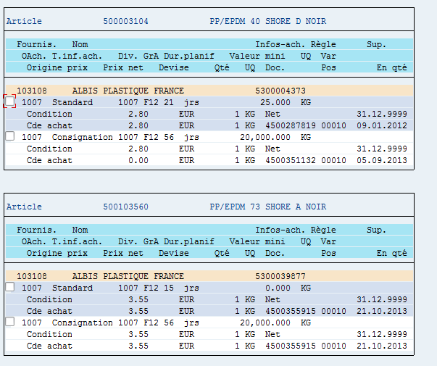
Figure 1 Purchase info record - example AR France

Create a purchase requisition with item category “K”
For AR France: order type C
For AR France: be careful with tax code:
- If supplier is out of Europe : E9 → huge impact on TVA declaration

Create a purchase order with item category “K”
- The goods receipt will be posted to the consignment stock
- No invoice receipt will be generated for the item.
- The net price is zero

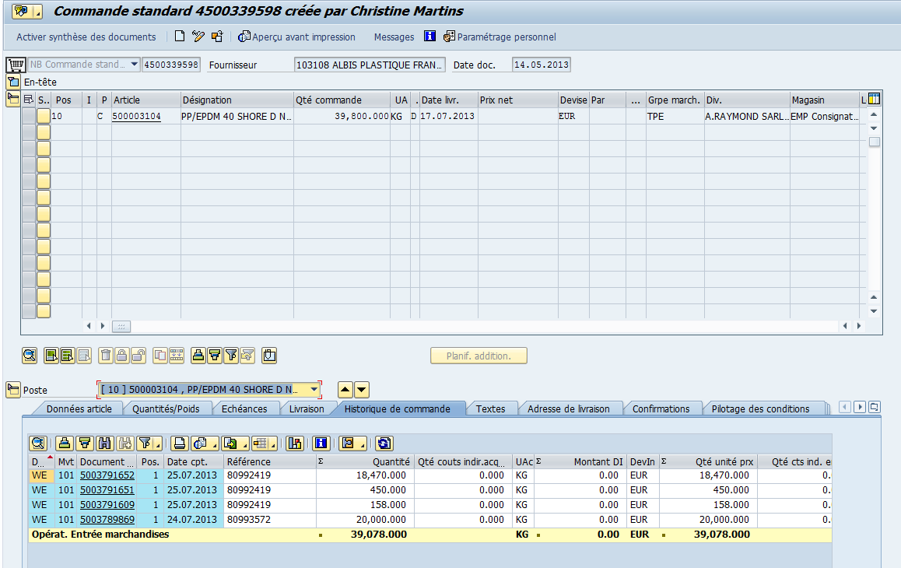
Figure 2 Purchase order - example AR France

Non valuated goods receipt (MIGO)
After a goods receipt for consignment material has been posted, the consignment stock of the material increases. The consignment stock is available for MRP.
However, the material's valuated stock does not increase since the consignment stock still belongs to the vendor.

Figure 3 Good receipt on purchase order

Quality control (transfer from “Q” to unrestricted use)

Display consignment stock with MB54

Goods issue on production order from consignment stock
You can only post a goods issue from consignment stock to consumption if the material belongs to unrestricted-use stock. If the consignment material is in quality inspection or blocked stock, you must first transfer it to the unrestricted-use stock.
After the goods issue, the vendor is due the net value of the goods issue.

Transfer from consignment stock to own stock
Supposing you agreed with the vendor that after six months you will take over ownership of the remaining consignment stock. To do this, carry out the following goods movement: MB1B
Enter the plant and storage location. Movement type 411 with special stock indicator K
Enter: the collective entry screen appears.
Enter the vendor, material, and quantity. Only enter a receiving storage location if the material should be stored in another storage location.
Post the document.
The transfer results in a liability towards the vendor.

AR France : we create a new consignment stock location in SAP : EMPC

Scrap consignment stock
Supposing you agreed with the vendor to scrap consignment stock.
To do this, carry out the following goods movement: MB1A
Enter the plant and storage location. Movement type 551 with special stock indicator K
Enter: the collective entry screen appears.
Enter the cost center, vendor, material, quantity, storage location and batch.
Post the document.
The transfer results in a liability towards the vendor.

Goods return to vendor
Supposing you agreed with the vendor to return consignment stock.
To do this, carry out the following goods movement: MIGO
Movement type 122 with special stock indicator K
Enter the material document and the system retrieves all data from the purchase order.
Post the document.
In this case, there is no settlement to post.
The purchase order is reopened for a new goods receipt.

Settling Consignment Liabilities
Removing material from consignment stock or transferring material to your company’s own stock results in liabilities towards the vendor. You should settle these liabilities at regular intervals.

Consignment materials are settled without the vendor issuing an invoice, as the vendor company is unable to track withdrawals directly. The vendor can only manage its consignment stock by taking deliveries and payments into account.

You do not expect an invoice from the vendor for goods withdrawals from consignment stock. Instead you settle posted withdrawals and return deliveries yourself and send the vendor a statement of the settlement. You can perform this settlement periodically in the background.

To cancel settlement, you have to cancel the documents in Inventory Management and start consignment settlement. The system generates a credit memo for the returned document. If the consignment prices have changed since the original goods receipt, post the credit memo in Financial Accounting. Clear the invoice and the credit memo in Financial Accounting.

Consignment settlement is not connected to the purchasing information system, because the purchase order history is not updated during consignment settlements.

You cannot make any net postings during consignment settlement. This means that you cannot calculate any cash discounts. To take cash discounts into account, you must include these in the consignment price. This ensures that the cash discount is implicitly posted during the goods withdrawal and settlement.

You cannot settle delivery costs.

Note, that consignment settlement cannot be performed simultaneously by several users. The material documents are not blocked during settlement, which means that duplicate settlement documents can be created.

The liabilities account for consignment settlement must not be flagged as Post automatically only, and must not be defined as a reconciliation account.

Physical Inventory of Consignment Material
You process a physical inventory by:
- Creating a physical inventory document for special stock “K”
- Entering the physical inventory count
- Posting inventory differences

Example on GPP

Master data
Finished part = 151669000 BRACKET WIRING FIX LH
Component = 500121293 C67S 170,0 x 1,00
Supplier = 104972 LAMINCER S.A.

MM02: Change procurement type of the raw material

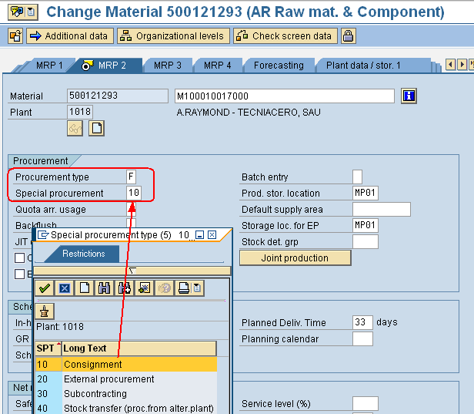

ME11 create a consignment PIR

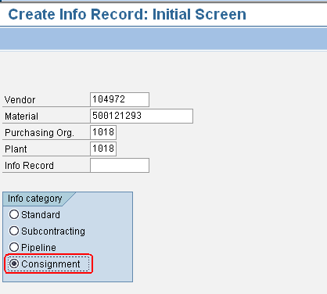
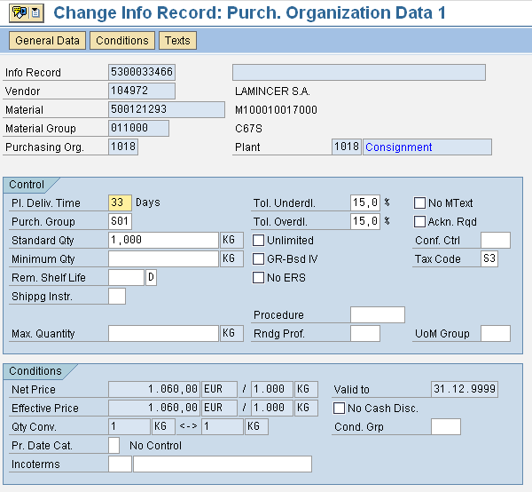

Purchasing info record 5300033466 1018 K 1018 created
The price corresponds to the value when the raw material will be consumed from the consignment stock.

Flow
MRP runs and create purchase requisitions with item category K:

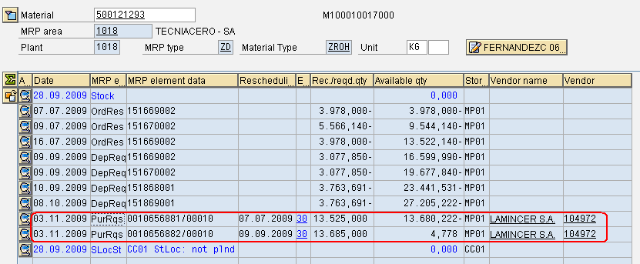

Convert the purchase requisition into purchase order with item category K:

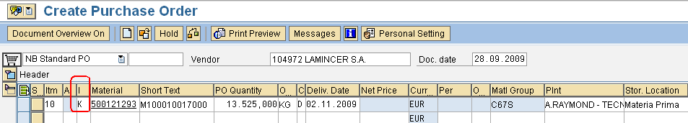

Net price = 0
There is no invoice tab
PO = 4500195550

Do the goods receipt with MIGO:
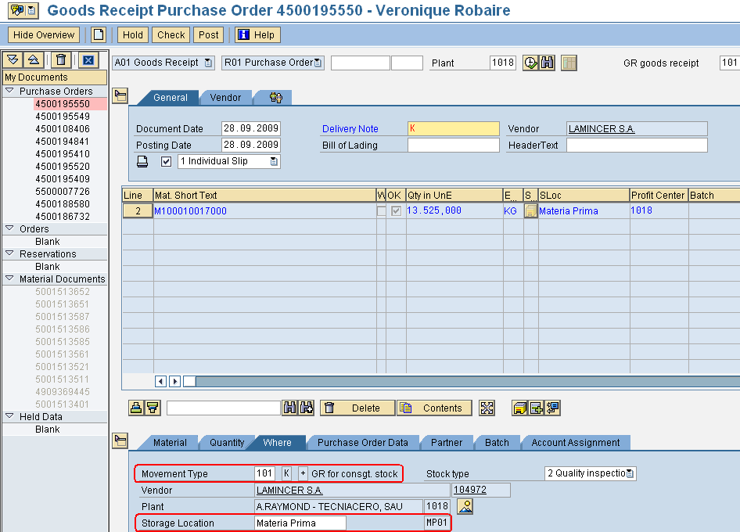

Save. Material document 5001513653 posted.

There is no accounting document linked with the material document. The parts are in stock but non- valuated.

Do the quality control to transfer stock from quality to unrestricted use.

Display consignement stock with MB54:

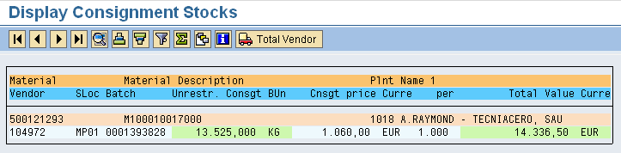

The stock is non-valuated but with this transaction you know the value of it.

Production order for the finished part = 10668978 (ZP01 type)

Transaction MB1A to do the goods issue from production order: click on button “To order…”
In the pop-up, enter order number and special stock indicator “K”.

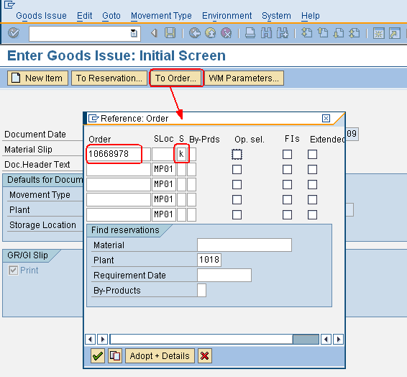

Press Enter
Enter the supplier and the batch in the material document before saving

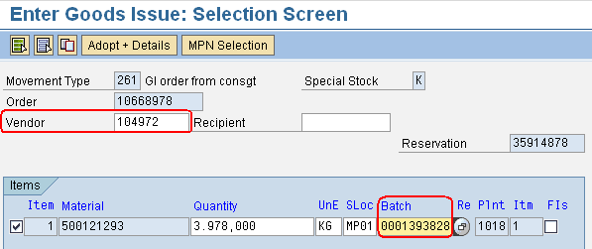

Document 4909369916 posted with linked FI document = 4500090607.

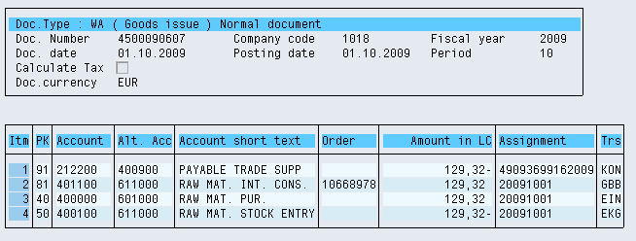

Display and settle withdrawals and cancellations with MRKO
Display mode:

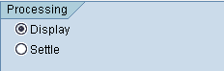

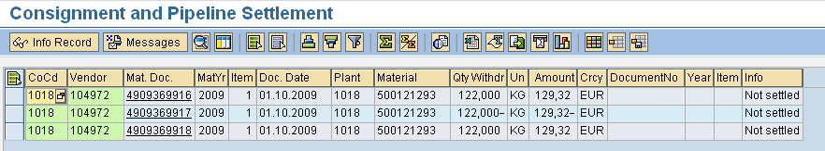

Settle mode:

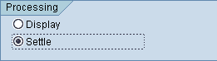

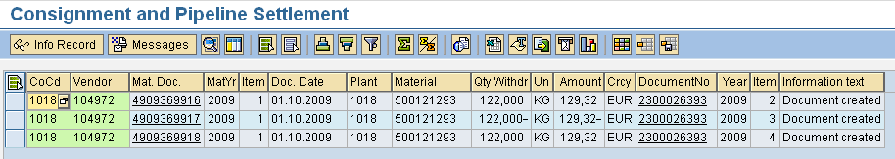

Print report immediately or later with MR91
AR France : on SP02, you can get the document printed
If the vendor language in XK02 is EN, the form will be printed in language EN
If the vendor language in XK02 is ES, the form will be printed in language ES

Printing in EN:
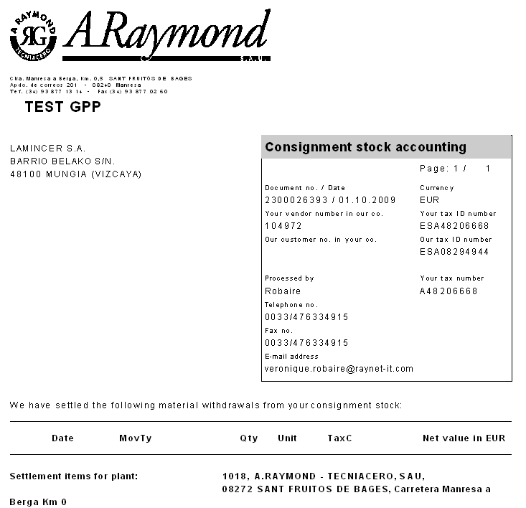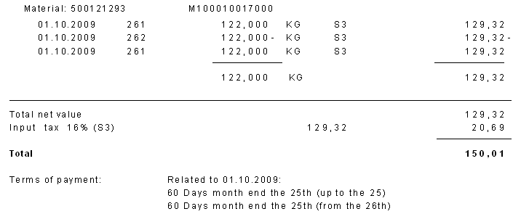
Transfer from consignment stock to own stock: transaction MB1B movement 411 K

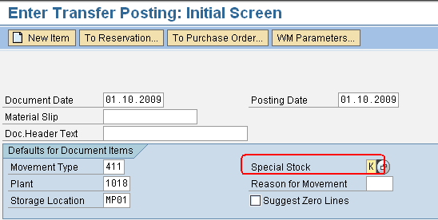

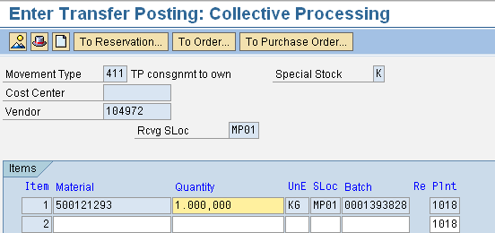

Document 4909369919 posted

Inventory from consignment stock: transaction MI10

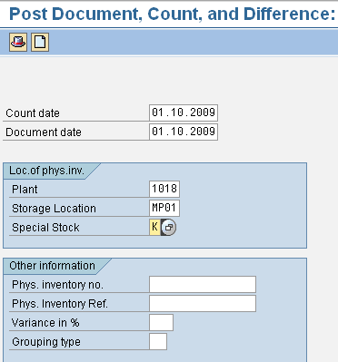

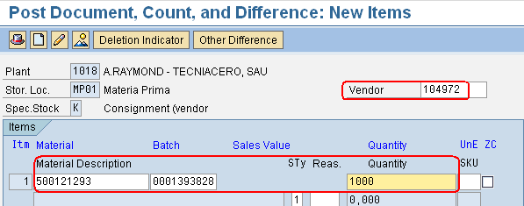

Enter the vendor, material, batch and counted quantity.
Save
Diffs in phys. inv. doc. 100173784 posted with m. doc. 4909369920

Transfer from consignment stock to own stock and Inventory from consignment stock have to be settle with MRKO:

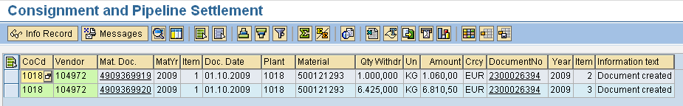

Printing in ES:

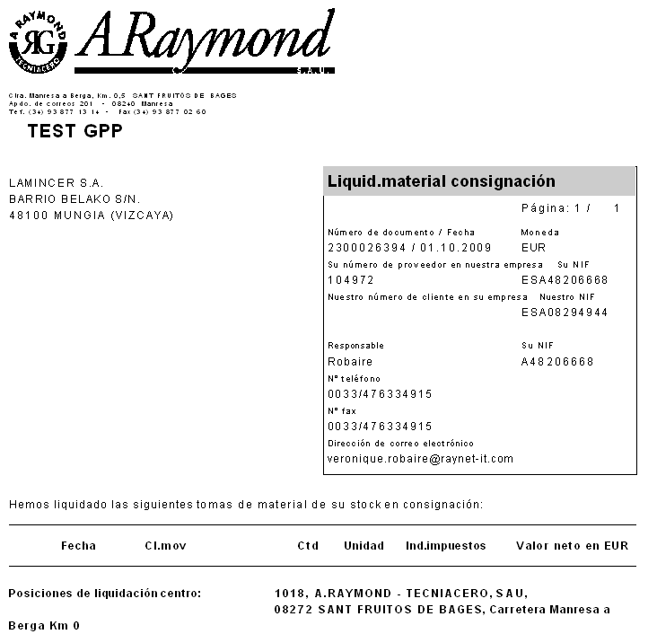
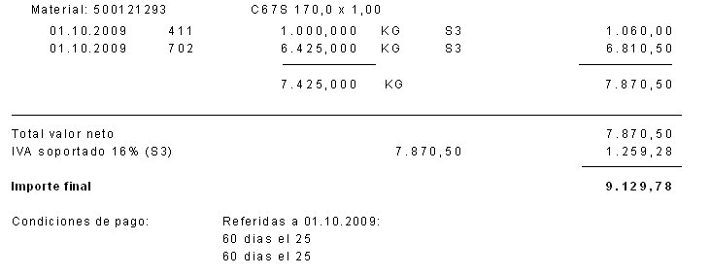

Check stock with MB54

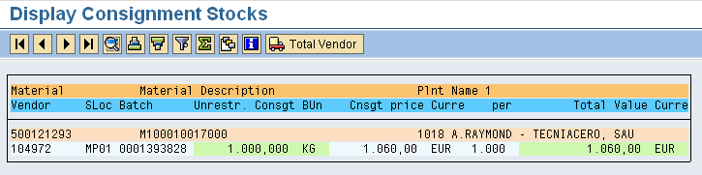

Scrap consignment stock:
Transaction MB1A movement 551 / K

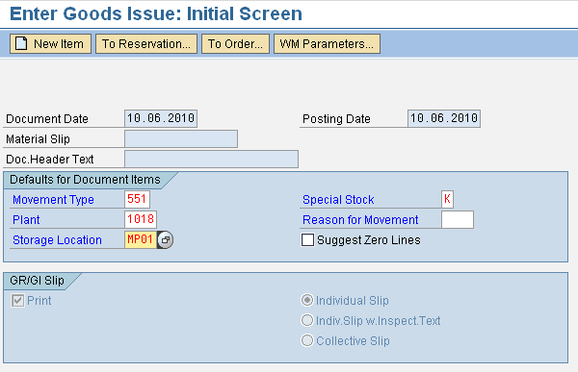

Enter the cost center, the vendor, the material, quantity and batch:

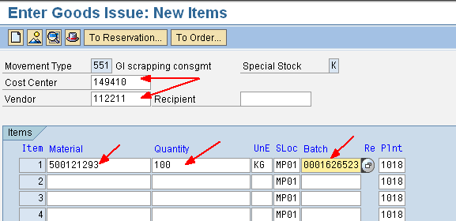

Save the document.
Document 4910759779 posted on GPP.

A settlement has to be done in MRKO:

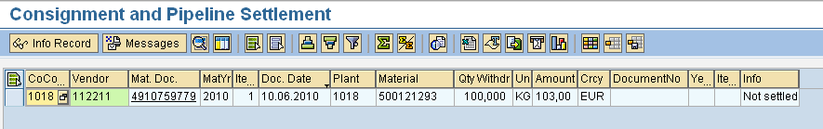

Return consignment stock to supplier:
Transaction MIGO movement 122 / K

When you enter the reference to the material document of the goods receipt, the system automatically retrieve the K stock type.

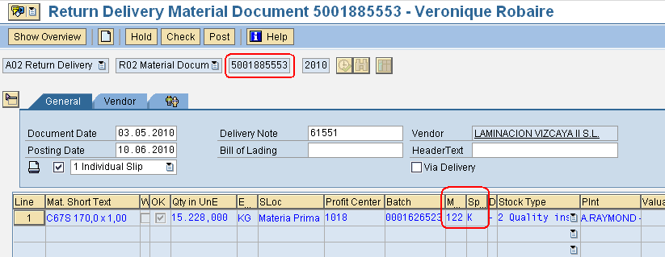

Save the document

Material document 5001890623 posted on GPP.

In this case, there is no settlement to post. The purchase order is reopened for a new goods receipt.

Reversal
In case of problem, the procedure to reverse a supplier consignment invoice is to
- Reverse with MBST transaction the 411K movement with a 412K movement
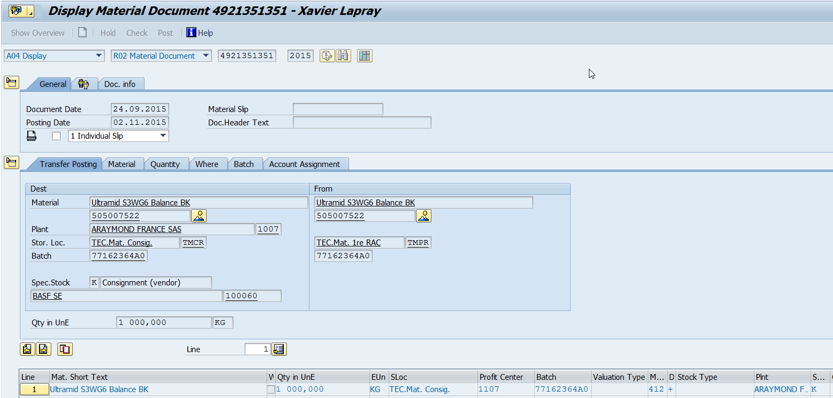
- Run again MRKO ➔ it will generate a credit note
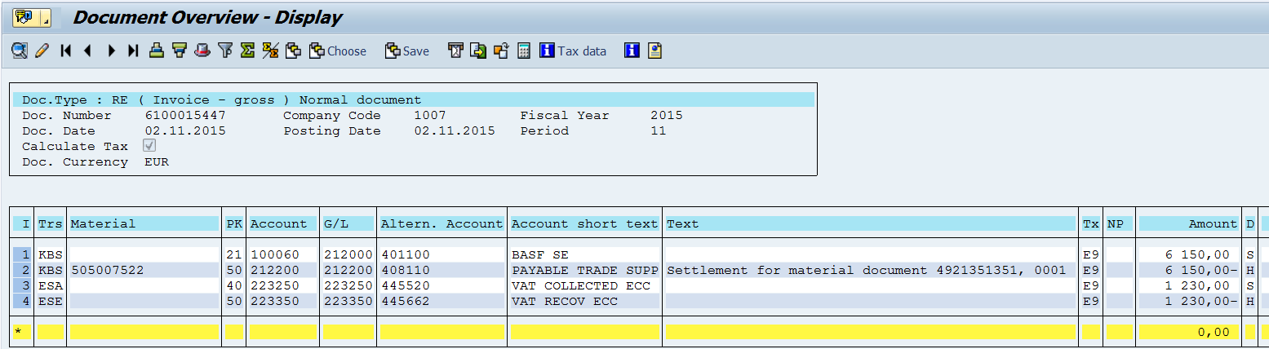

If the problem is discovered later, it is possible that the movement 412K cannot be done directly:
- If a 311 movement has taken place then a cancellation with MBST has to be done before the 412K cancellation ➔ it will generate a 312 movement type
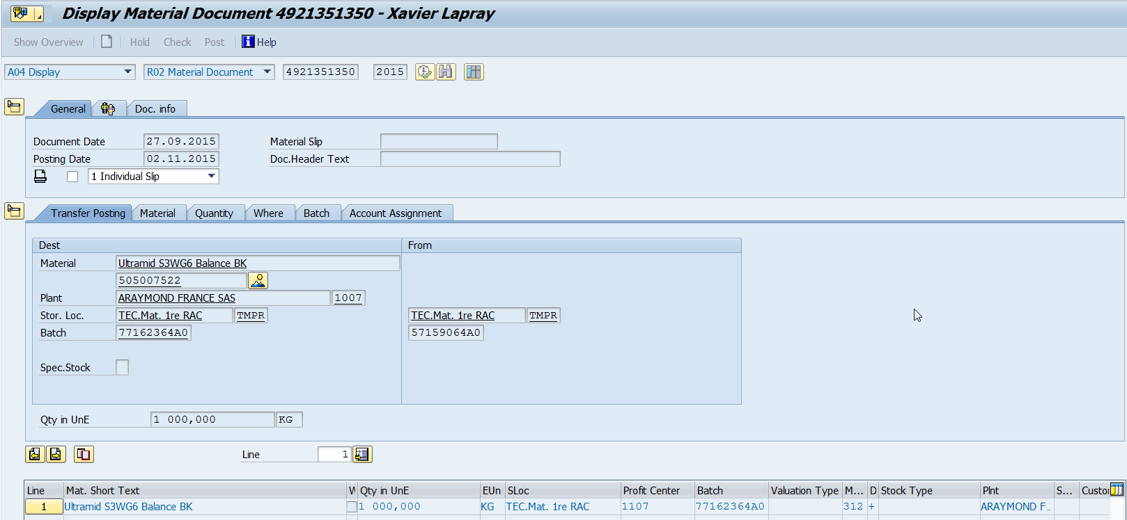
- Then the next steps are the same

If the problem is discovered much later and if there is not enough stock then it will be necessary to proceed with the following steps:
- Creation of a stock with the initial batch number with transaction MB1A and movement type 202 in storage location EMP ; this movement has to be assigned to a cost center
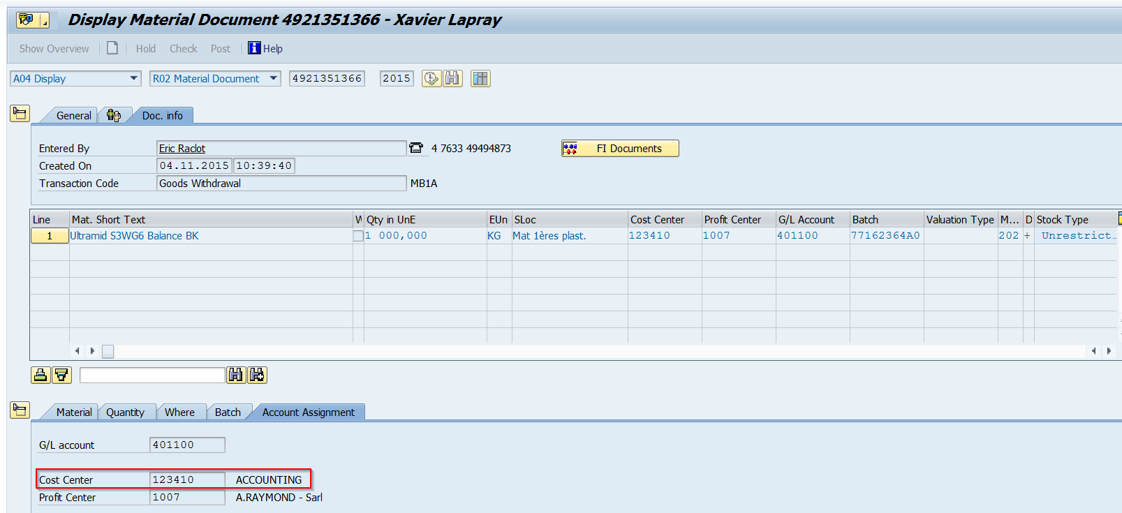

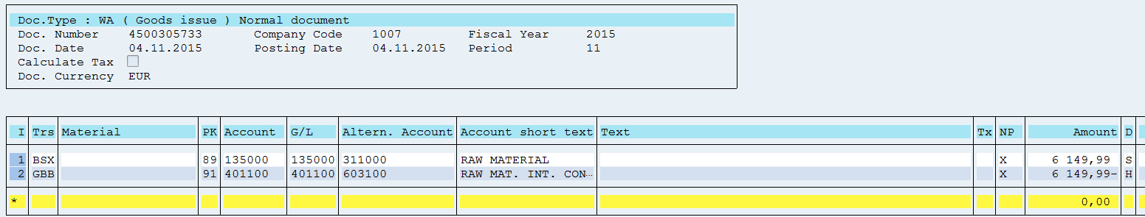
- Transfer to the consignment storage location with transaction MB1B and movement type 412K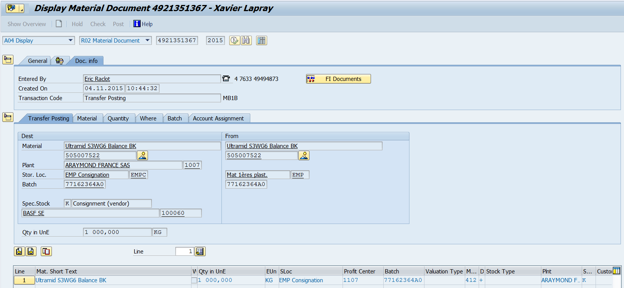
- Cancellation of the GR with transaction MIGO and with movement type 102
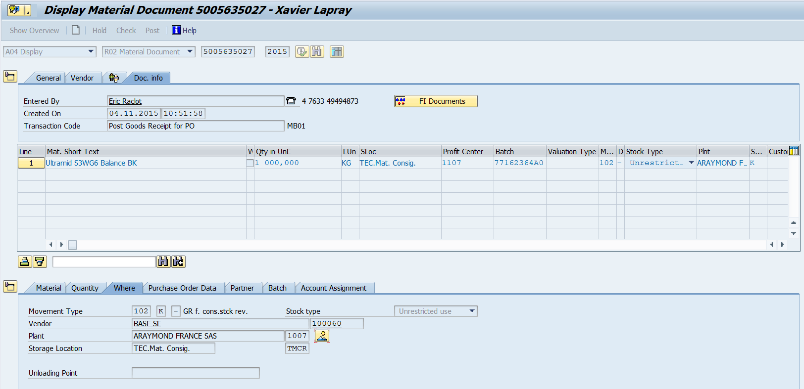
- Adjustment of the purchasing price in the Purchase Info Record with ME12 transaction
- GR with MIGO and with movement type 101K

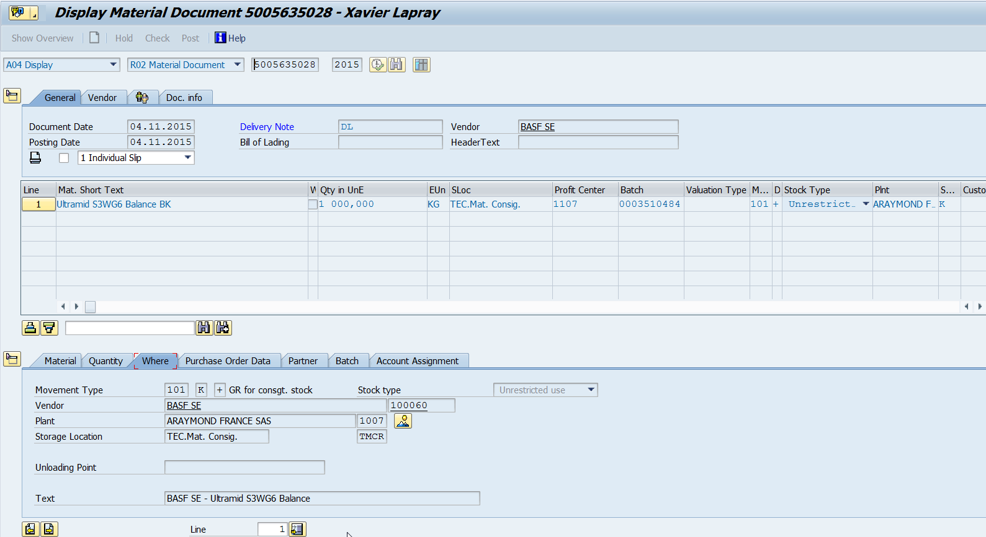
- Transfer to the own storage location with transaction MB1B and movement type 411K
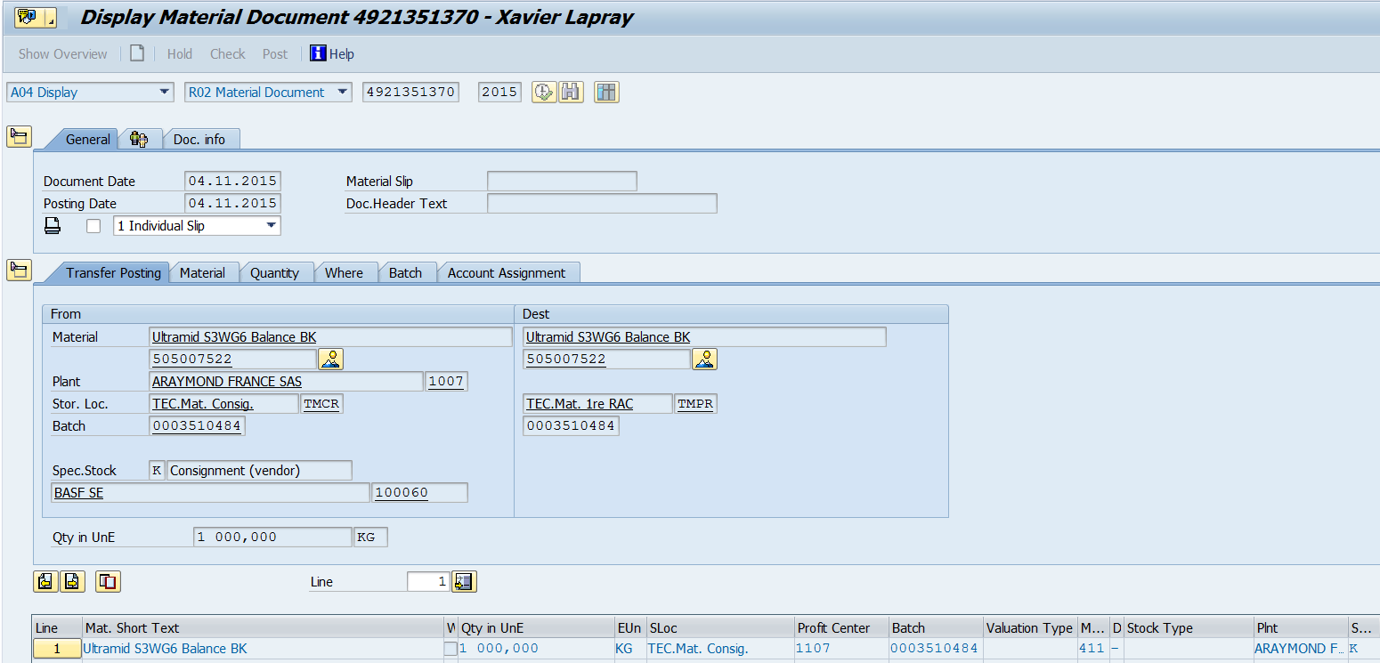
- Run MRKO ➔ the credit note will b issued with the old price and the new invoice will be issued with the old price
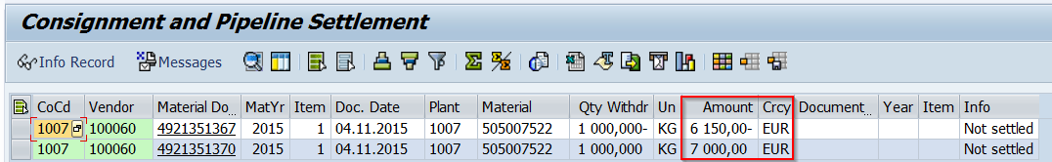

- Cancellation of the initial fictive stock (created at step 1) with transaction MB1A and with movement type 201
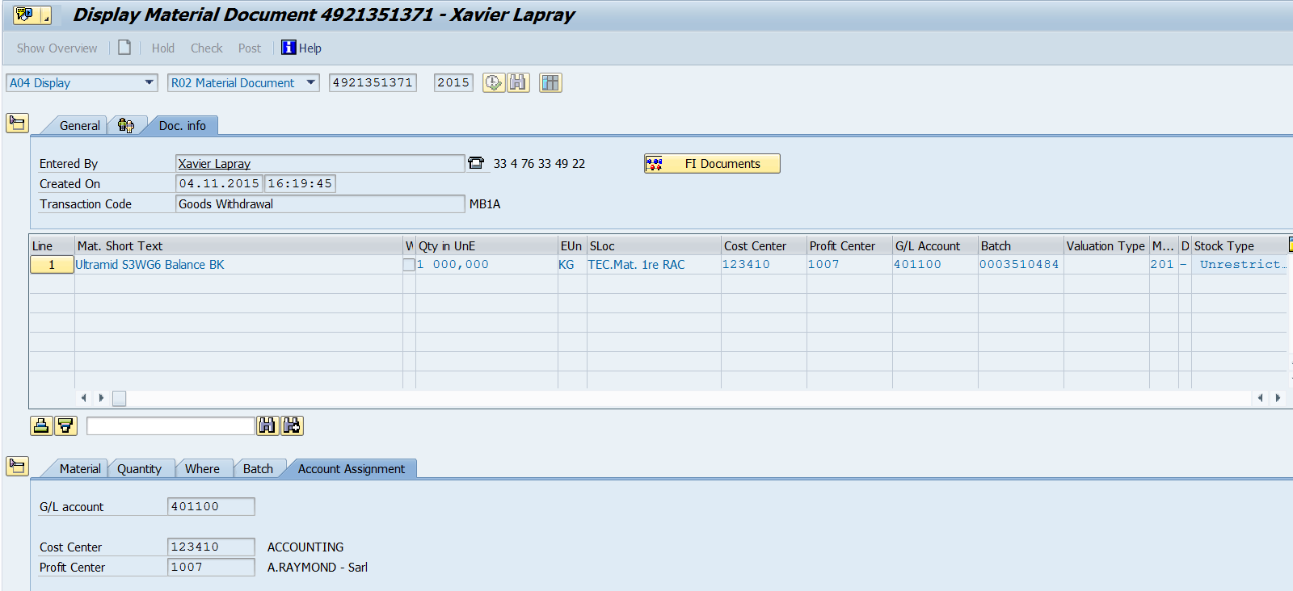

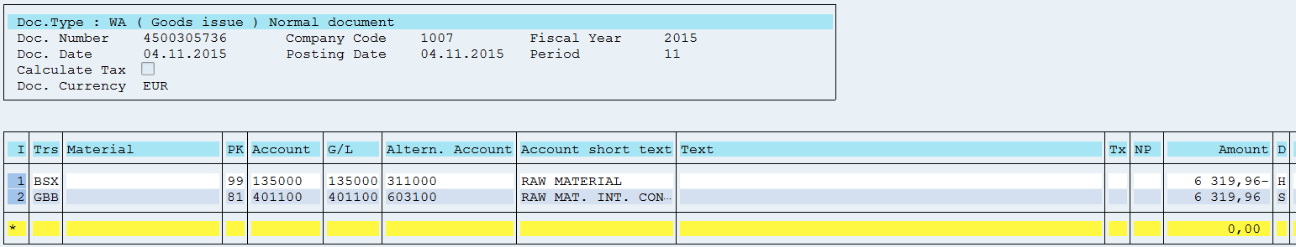
AR France : info on price change management
Need to agree with the supplier if the price change will occur at the end of the consumption of the complete truck or when we consume the material.
For instance:
- Delivery of complete truck on 10th December
- New price agree for 1st January but last delivery has not been consume
If we change the price in PIR with valid date of 1st January, all material will be invoice at this price.
We need to agree with the supplier of the implementation of new price before changing price on PIR.

AR France: info for DEB (Declaration Echange de Biens):

Dans le cas de matière en stock consignation fournisseurs expédiée et facturée par un fournisseur hors France, 2 règles peuvent s’appliquer :
- Si consommation de la matière dans les 3 mois à réception de la marchandise :
  - la DEB est à établir à la réception de la marchandise
  - procédure : R11
  - nature de transaction : 12
  - ligne 03 de la CA3.
- Si consommation de la matière dans plus de 3 mois après la réception de la marchandise :
  - la DEB est à établir à la réception de la marchandise
  - procédure : R19
  - nature de transaction : 12
  - ligne 03B de la CA3.

ARaymond contractualise avec ces fournisseurs selon la règle : « consommation de la matière réceptionnée sous 6 mois maximum». N’ayant pas la certitude de consommer la matière dans une durée pré-définie à réception de la matière, nous avons défini une règle pour tous les stocks de consignation : voir règle b décrite ci-dessus.

